# INVENTORY MANAGEMENT SYSTEM

CODE :

import java.util.*;

class Product {

String productId;

String productName;

int quantity;

double price;

Product(String id, String name, int qty, double price) {

this.productId = id;

this.productName = name;

this.quantity = qty;

this.price = price;

}

String display() {

return "ID: " + productId + ", Name: " + productName + ", Qty: " + quantity + ", Price: " + price;

}

}

// Inventory Manager

class InventoryManager {

HashMap<String, Product> inventory = new HashMap<>();

void addProduct(Product p) {

if (inventory.containsKey(p.productId)) {

System.out.println("Product ID already exists.");

} else {

inventory.put(p.productId, p);

System.out.println("Product added.");

}

}

void updateProduct(String id, int qty, double price) {

if (inventory.containsKey(id)) {

Product p = inventory.get(id);

p.quantity = qty;

p.price = price;

System.out.println("Product updated.");

} else {

System.out.println("Product not found.");

}

}

void deleteProduct(String id) {

if (inventory.containsKey(id)) {

inventory.remove(id);

System.out.println("Product deleted.");

} else {

System.out.println("Product not found.");

}

}

void viewInventory() {

if (inventory.isEmpty()) {

System.out.println("Inventory is empty.");

} else {

for (Product p : inventory.values()) {

System.out.println(p.display());

}

}

}

}

// Main menu

public class Main {

public static void main(String[] args) {

Scanner sc = new Scanner(System.in);

InventoryManager manager = new InventoryManager();

while (true) {

System.out.println("\n1. Add Product");

System.out.println("2. Update Product");

System.out.println("3. Delete Product");

System.out.println("4. View Inventory");

System.out.println("5. Exit");

System.out.print("Enter choice: ");

int choice;

if (sc.hasNextInt()) {

choice = sc.nextInt();

sc.nextLine(); // clear newline

} else {

System.out.println("Invalid input.");

sc.next(); // skip invalid input

continue;

}

if (choice == 1) {

System.out.print("Enter Product ID: ");

String id = sc.nextLine();

System.out.print("Enter Product Name: ");

String name = sc.nextLine();

System.out.print("Enter Quantity: ");

int qty = sc.nextInt();

System.out.print("Enter Price: ");

double price = sc.nextDouble();

sc.nextLine();

Product p = new Product(id, name, qty, price);

manager.addProduct(p);

} else if (choice == 2) {

System.out.print("Enter Product ID to update: ");

String id = sc.nextLine();

System.out.print("Enter new Quantity: ");

int qty = sc.nextInt();

System.out.print("Enter new Price: ");

double price = sc.nextDouble();

sc.nextLine();

manager.updateProduct(id, qty, price);

} else if (choice == 3) {

System.out.print("Enter Product ID to delete: ");

String id = sc.nextLine();

manager.deleteProduct(id);

} else if (choice == 4) {

manager.viewInventory();

} else if (choice == 5) {

System.out.println("Exiting...");

break;

} else {

System.out.println("Invalid choice.");

}

}

sc.close();

}

}

OUTPUT :

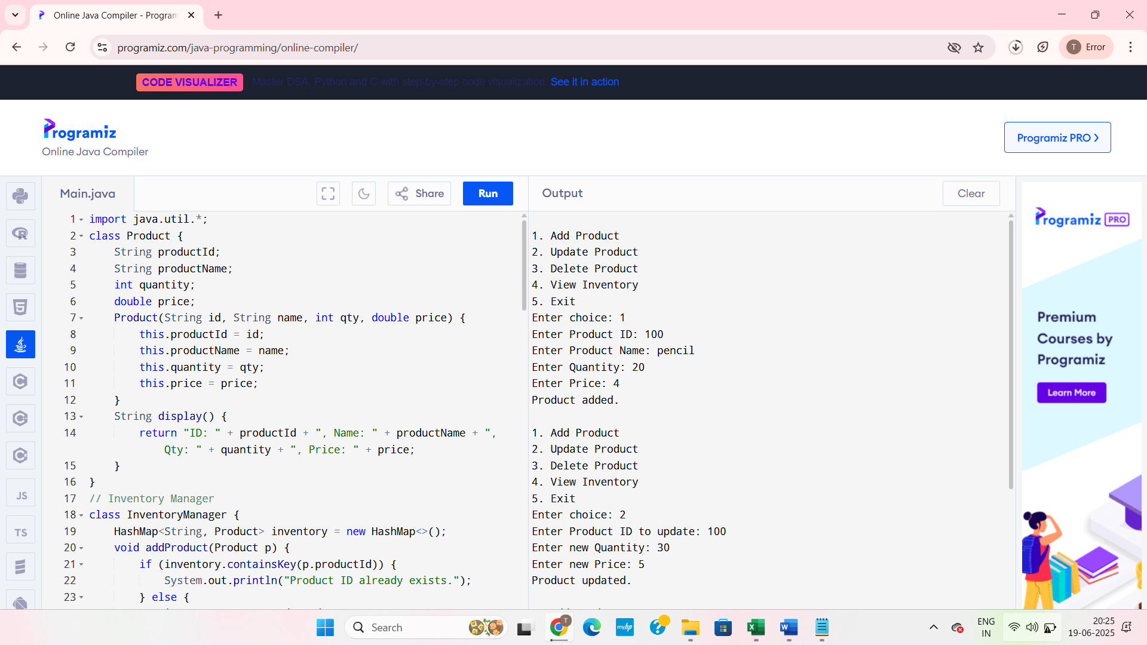

FIG : Products are added and updated

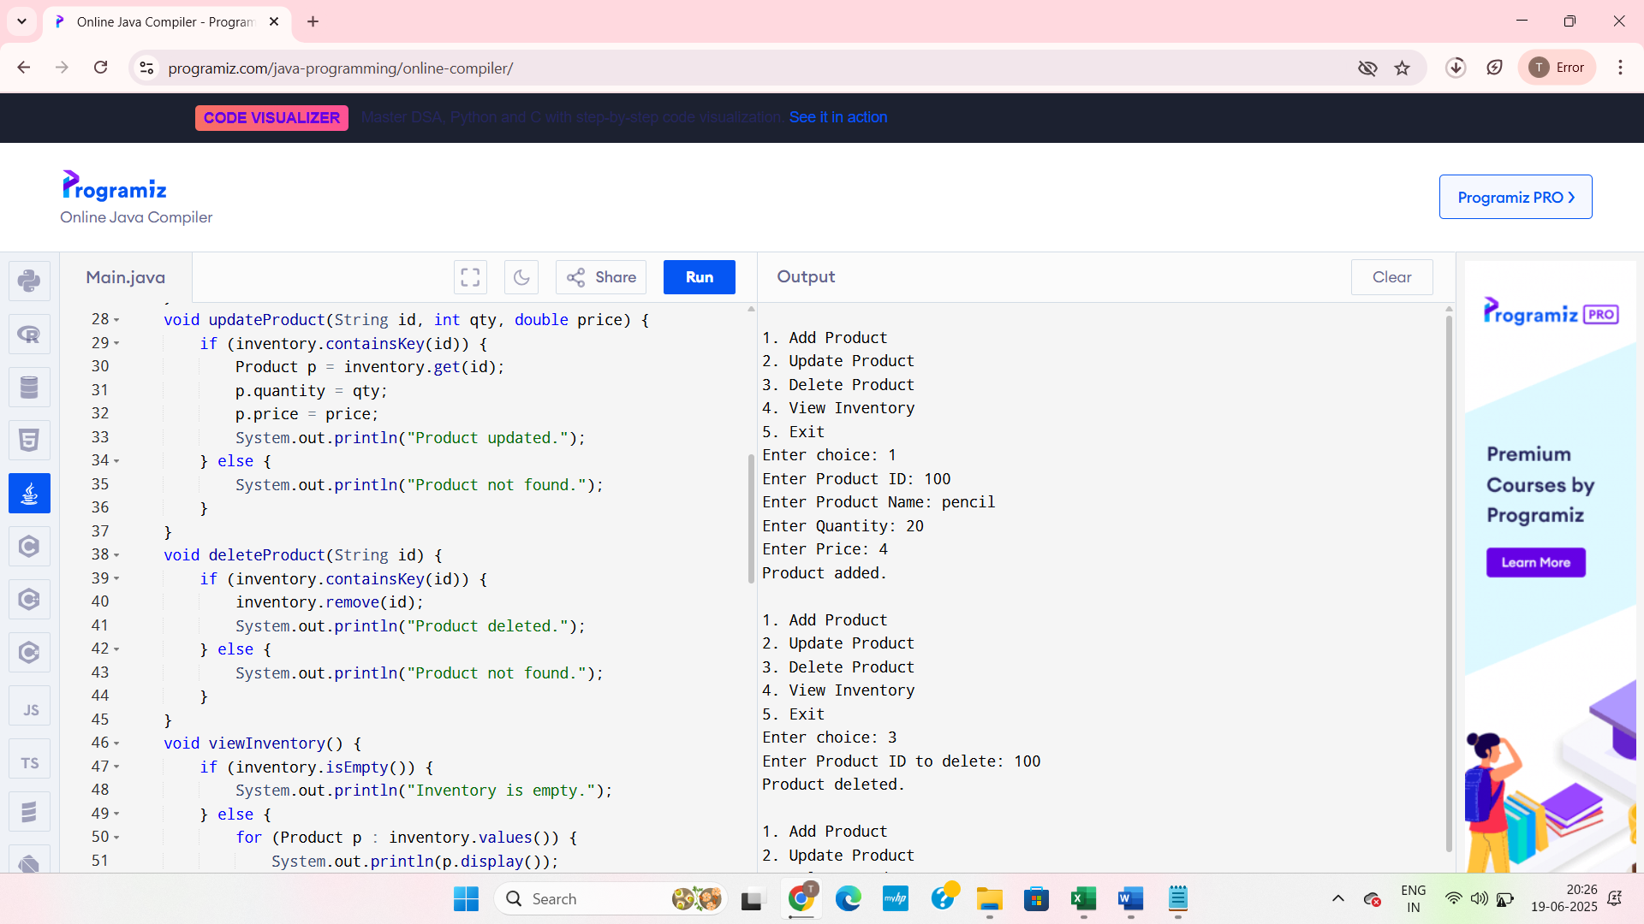

FIG : Deleting

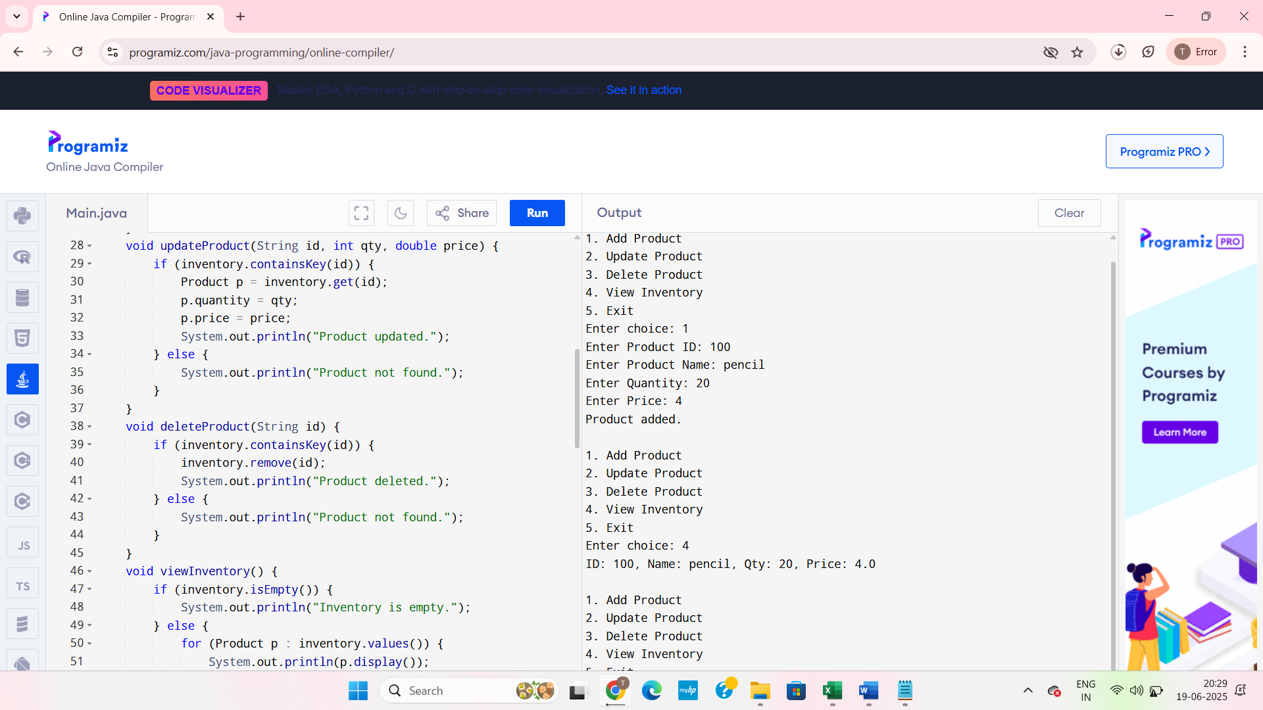

FIG : viewing

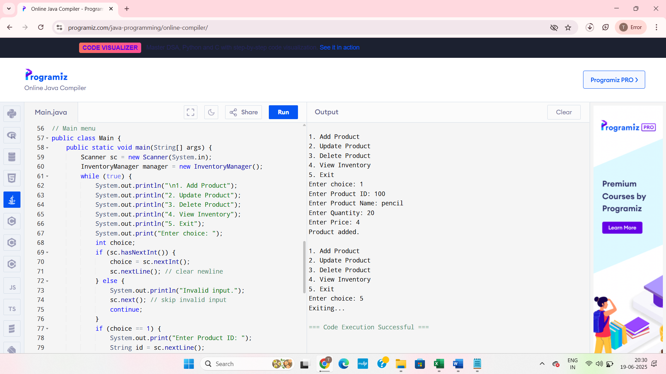

FIG : Exiting